MODEL ENGINEERING COLLEGE, THRIKKAKARA

DEPARTMENT OF COMPUTER ENGINEERING



RECORD OF PRACTICAL WORKS

EST 102 PROGRAMMING IN C

CLASS: CS 2 B (2019 Ad.)

Name of Student: ADITHYA A

Roll No: 03

EXP No.: 01

Hello World

AIM

Display a message in console using Java.

PROGRAM

// First program

/*

This is a simple Java program.

Call this file "Example.java".

*/

class Main {

// Your program begins with a call to main().

public static void main(String args[ ]) {

System.out.println("This is a simple Java program.");

}

}

OUTPUT

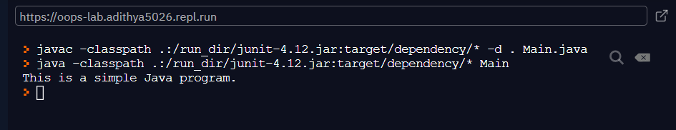

EXP No.: 02

VARIABLE DECLARATION

AIM

Demonstrate a Java program that uses variable declaration.

PROGRAM

/*

Here is another short example.

Call this file "Example2.java".

*/

class Main {

public static void main(String args []) {

int num; // this declares a variable called num

num = 100; // this assigns num the value 100

System.out.println("This is num: " + num);

num = num * 2;

System.out.print("The value of num * 2 is ");

System.out.println(num);

}

}

OUTPUT

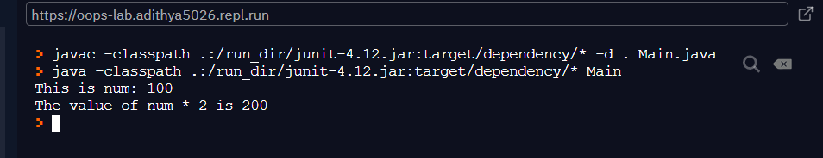

EXP No.: 03

IF STATEMENT

AIM

Program to Illustrate the use of ‘if’ in Java

PROGRAM

/*

Demonstrate the if.

Call this file "IfSample.java".

*/

class Main {

public static void main(String args[]) {

int x, y;

x = 10;

y = 20;

if(x < y) System.out.println("x is less than y");

x = x * 2;

if(x == y) System.out.println("x now equal to y");

x = x * 2;

if(x > y) System.out.println("x now greater than y");

// this won't display anything

if(x == y) System.out.println("you won't see this");

}

}

OUTPUT

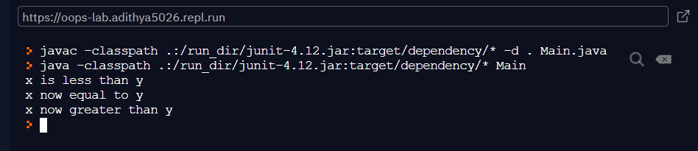

EXP No.: 04

FOR LOOP IN JAVA

AIM

Program to Demonstrate ‘for’ loop in Java

PROGRAM

/*

Demonstrate the for loop.

Call this file "ForTest.java".

*/

class Main {

public static void main(String args[ ]) {

int x;

for(x = 0; x<10; x=x+1)

System.out.println("This is x: " + x);

}

}

OUTPUT

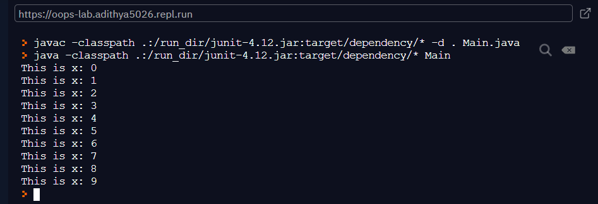

EXP No.: 08

LINEAR SEARCH

AIM

Program to Read n integers, store them in an array and search for an element in the array using an algorithm for Linear Search

PROGRAM

#include <stdio.h>

int main(){

int n, i,a[100],key,flag=-1;

printf("Enter number of elements: \n");

scanf("%d",&n);

printf("Enter the list of elements..\n");

for(i=0;i<n;i++)

scanf("%d",&a[i]);

printf("Enter the element to search..\n");

scanf("%d",&key);

for (i=0;i<n;i++)

if (a[i]==key){

flag=1;

break;

}

if(flag==1)

printf("Element is found at index %d Position %d\n",i,i+1);

else

printf("Element is not found\n");

}

OUTPUT

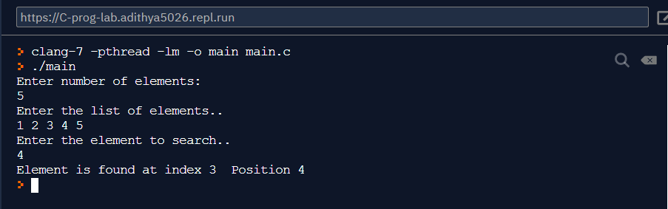

EXP No.: 09

BUBBLE SORT

AIM

Program to Read n integers, store them in an array and sort the elements in the array using Bubble Sort algorithm.

PROGRAM

#include <stdio.h>

int main(){

int n, i,j,a[100],temp,flag;

printf("Enter number of elements: \n");

scanf("%d",&n);

printf("Enter the list of elements..\n");

for(i=0;i<n;i++)

scanf("%d",&a[i]);

for(i = 0; i < n; i++){

for(j = 0; j < n-i-1; j++){

flag = 0;

if( a[j] > a[j+1]){

temp = a[j];

a[j] = a[j+1];

a[j+1] = temp;

flag = 1;

}

}

if ( flag==0)

break;

}

printf("The sorted list is ...\n");

for(i=0;i<n;i++)

printf("%d\n",a[i]);

}

OUTPUT

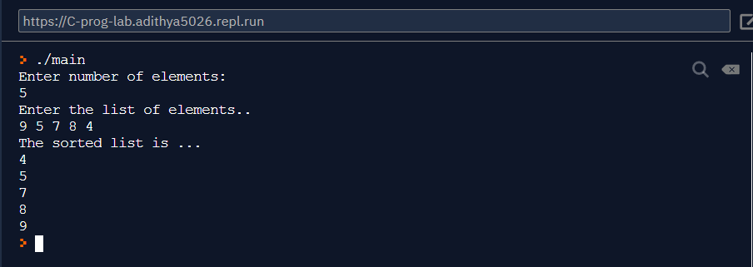

EXP No.: 10

PALINDROME STRING

AIM

Program to Read a string (word), store it in an array and check whether it is a palindrome word or not.

PROGRAM

#include <stdio.h>

#include <string.h>

int main()

{

char str[100],rstr[100];

int i,j,ln;

printf("Enter the string(word): ");

scanf("%s",str);

ln=strlen(str);

for(i=ln-1,j=0;i>=0;i--,j++)

rstr[j]=str[i];

rstr[j]='\0';

if(strcmp(rstr,str)==0)

printf("Palindrome\n");

else

printf("Not Palindrome\n");

}

OUTPUT

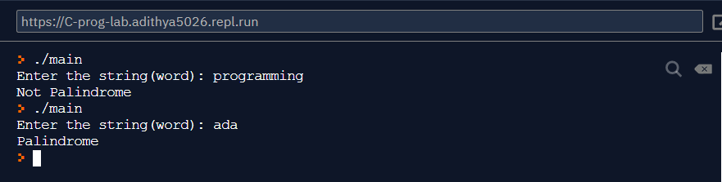

EXP No.: 11

STRING CONCATENATION

AIM

Program to Read two strings (each one ending with a $ symbol), store them in arrays and concatenate them without using library functions.

PROGRAM

#include <stdio.h>

#include <string.h>

int main()

{

char str1[100],str2[100];

int i,j;

printf("Enter the string1: ");

fgets(str1,100,stdin);

printf("Enter the string2: ");

fgets(str2,100,stdin);

for(i=0;str1[i]!='$';i++);

for(j=0;str2[j]!='$';j++,i++)

str1[i]=str2[j];

str1[i]='\0';

printf("concatenated string is \n");

printf("%s\n",str1);

}

OUTPUT

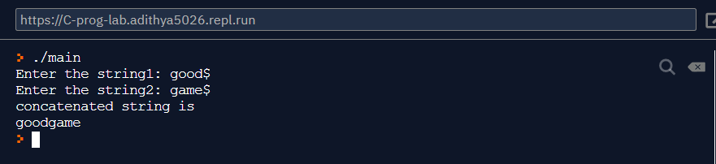

EXP No.: 12

VOWELS AND CONSONANTS IN A STRING

AIM

Program to Read a string (ending with a $ symbol), store it in an array and count the number of vowels, consonants and spaces in it.

PROGRAM

#include <stdio.h>

#include <string.h>

int main()

{

char str1[100];

int i,v=0,c=0;

printf("Enter the string:");

fgets(str1,100,stdin);

for(i=0;i<strlen(str1);i++){

switch(str1[i]){

case '\n':break;

case 'a':

case 'e':

case 'i':

case 'o':

case 'u': v++;

break;

default: c++;

break;

}

};

printf("Number of vowels %d\n",v);

printf("Number of consonants %d\n",c);

}

OUTPUT

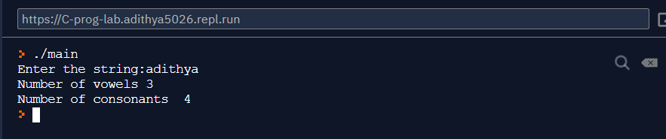

EXP No.: 13

ADDITION OF DISTANCE BETWEEN TWO POINTS USING STRUCTURE VARIABLES

AIM

Program to Read two inputs each representing the distances between two points in the Euclidean space, store these in structure variables and add the two distance values.

PROGRAM

#include <stdio.h>

#include <string.h>

int main()

{

struct{

float x;

float y;

}dist1,dist2,dist3;

printf("Enter x1 and y1 \n");

scanf("%f %f",&dist1.x,&dist1.y);

printf("Enter x2 and y2 \n");

scanf("%f %f",&dist2.x,&dist2.y);

dist3.x = dist1.x + dist2.x;

dist3.y = dist1.y + dist2.y;

printf("Sum of distances x=%f y=%f",dist3.x,dist3.y);

}

OUTPUT

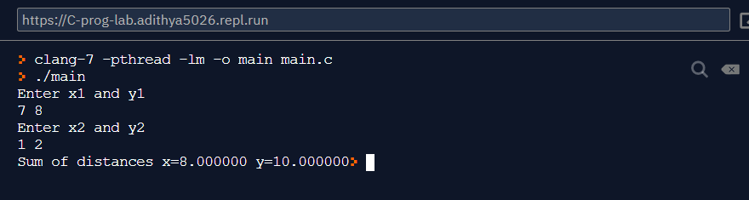

EXP No.: 14

PRINT DATA OF EMPLOYEE USING STRUCTURE

AIM

Program to read and print data of n employees (Name, Employee Id and Salary) , Using structure.

PROGRAM

#include <stdio.h>

struct Employee

{

int empid;

char name[50];

int salary;

}emp[50];

int main()

{ int n,i;

printf("Enter the number of employees\n");

scanf("%d",&n);

for(i=0;i<n;i++)

{

printf("Enter the employee details-%d\n",i+1);

printf("Employee id:");

scanf("%d",&emp[i].empid);

getchar();

printf("Employee name:");

scanf("%[^\n]",emp[i].name);

printf("Employee salary:");

scanf("%d",&emp[i].salary);

}

//printing the details

printf("Employee Details\n");

printf("Employee id Employee name Employee salary\n");

for(i=0;i<n;i++)

printf("%-15d %-15s %10d\n",emp[i].empid,emp[i].name,emp[i].salary);

}

OUTPUT

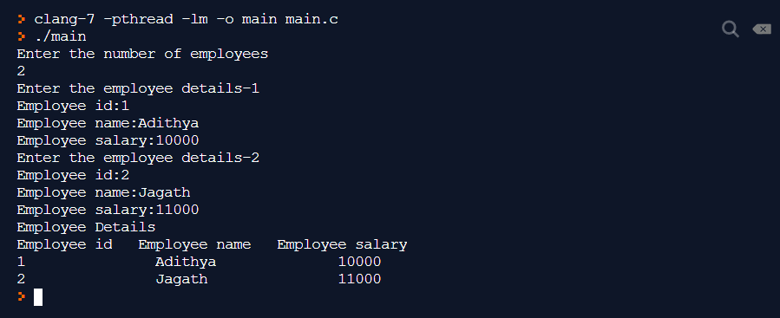

EXP No.: 15

UNION

AIM

Program to Declare a union containing 5 string variables (Name, House Name, City Name, State and Pin code) each with a length of C_SIZE (user defined constant). Then, read and display the address of a person using a variable of the union.

PROGRAM

#include <stdio.h>

#include <string.h>

#define C_SIZE 50

union Address

{

char name[C_SIZE];

char hname[C_SIZE];

char cityname[C_SIZE];

char state[C_SIZE];

char pin[C_SIZE];

};

int main()

{

union Address record1;

printf("Enter name:");

scanf("%[^\n]",record1.name);

getchar();

printf("Enter house name:");

scanf("%[^\n]",record1.hname);

getchar();

printf("Enter city name:");

scanf("%[^\n]",record1.cityname);

getchar();

printf("Enter state name:");

scanf("%[^\n]",record1.state);

getchar();

printf("Enter pin:");

scanf("%[^\n]",record1.pin);

printf("Union record1 values:\n");

printf(" Name : %s \n", record1.name);

printf(" House Name : %s \n", record1.hname);

printf(" City Name : %s \n\n", record1.cityname);

printf(" State name : %s \n", record1.state);

printf(" Pin : %s \n\n", record1.pin);

}

OUTPUT

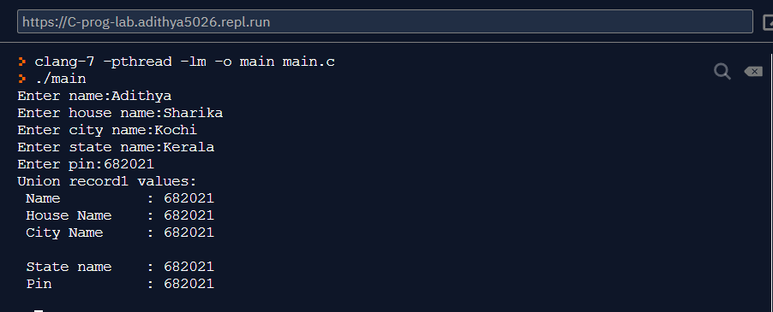

EXP No.: 16

RECURSION

AIM

Program to Find the factorial of a given Natural Number n using recursive and non recursive functions.

PROGRAM

#include <stdio.h>

long int fact_non_recur(int n)

{ int i;

long int f=1;

for(i=1;i<=n;i++)

f=f*i;

return f;

}

long int factr(int n)

{

if(n==0) return 1;

else

return (n*factr(n-1));

}

int main()

{

int n;

printf("Enter the number \n");

scanf("%d",&n);

printf("Factorial using non recursive function %d!=%ld\n",n,fact_non_recur(n));

printf("Factorial using recursive function %d!=%ld\n",n,factr(n));

}

OUTPUT

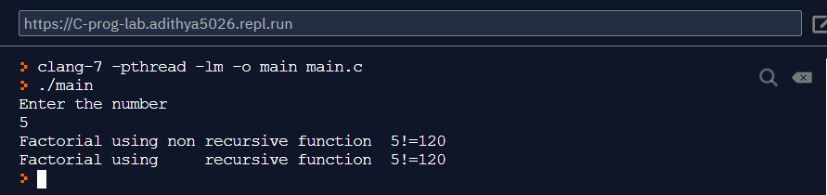

EXP No.: 17

REVERSING A WORD

AIM

Program to Read a string (word), store it in an array and obtain its reverse by using a user defined function.

PROGRAM

#include <stdio.h>

#include <string.h>

void reversestr(char str[])

{

int i,n;

char c;

n=strlen(str);

for(i=0;i<n/2;i++)

{ c=str[i];

str[i]=str[n-1-i];

str[n-1-i]=c;

}

}

int main()

{

char str[100];

printf("Enter the word \n");

scanf("%[^\n]",str);

reversestr(str);

printf("Reversed word is=%s\n",str);

}

OUTPUT

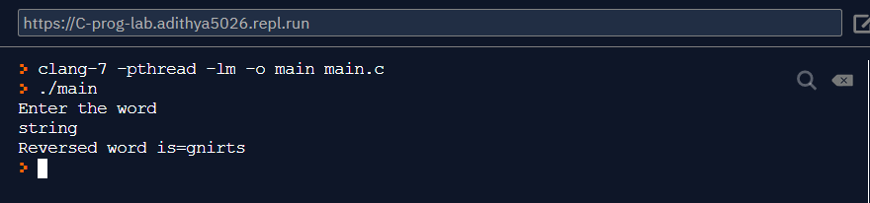

EXP No.: 18

2D MATRIX

AIM

Menu driven program for performing matrix addition, multiplication and finding the transpose. Use functions to

(i) read a matrix

(ii) find the sum of two matrices

(iii) find the product of two matrices

(iv) find the transpose of a matrix and (v) display a matrix.

PROGRAM

#include <stdio.h>

#include <stdlib.h>

void read_matrix(int a[][100],int m,int n)

{

int i,j;

printf("enter the elements row by row\n");

for(i=0;i<m;i++)

for(j=0;j<n;j++)

scanf("%d",&a[i][j]);

}

void display_matrix(int a[][100],int m,int n)

{

int i,j;

for(i=0;i<m;i++)

{

for(j=0;j<n;j++)

printf("%5d",a[i][j]);

printf("\n");

}

}

void add_matrix(int a[][100],int b[][100],int m,int n)

{

int i,j,c[100][100];

for(i=0;i<m;i++)

for(j=0;j<n;j++)

c[i][j]=a[i][j]+b[i][j];

printf("Sum of matrix...\n");

display_matrix(c,m,n);

}

void transpose(int a[][100],int m,int n)

{

int i,j,c[100][100];

for(i=0;i<m;i++)

for(j=0;j<n;j++)

c[j][i]=a[i][j];

display_matrix(c,n,m);

}

void multiply_matrix(int a[][100],int b[][100],int m1,int n1,int n2)

{

int c[100][100],i,j,k;

for (i = 0; i < m1; i++) {

for (j = 0; j < n2; j++) {

c[i][j] = 0;

for (k = 0; k < n1; k++)

c[i][j] += a[i][k] * b[k][j];

}

}

printf("Product of matrix...\n");

display_matrix(c,m1,n2);

}

int main()

{ int a[100][100],b[100][100],m1,n1,m2,n2,op;

printf("Enter the size of the matrix A row,column\n");

scanf("%d%d",&m1,&n1);

printf("Enter Matrix A\n");

read_matrix(a,m1,n1);

printf("Enter the size of the matrix B row column\n");

scanf("%d%d",&m2,&n2);

printf("Enter Matrix B\n");

read_matrix(b,m2,n2);

printf("Matrix A..\n");

display_matrix(a,m1,n1);

printf("Matrix B..\n");

display_matrix(b,m2,n2);

while(1)

{

printf("\n************************************\n");

printf("1.add 2.multiply 3.transpose 4.exit \n");

printf("Enter the option.....:");

scanf("%d",&op);

switch(op)

{

case 1: if(m1==m2 && n1==n2)

add_matrix(a,b,m1,n1);

else

printf("Incompatible matrix...cannot add..\n");

break;

case 2: if(n1==m2)

multiply_matrix(a,b,m1,n1,n2);

else

printf("Incompatible matrix...cannot multiply..\n");

break;

case 3: printf("Transpose of A..\n");

transpose(a,m1,n1);

printf("Transpose of B..\n");

transpose(b,m2,n2);

break;

case 4: exit(0);

}

}

}

OUTPUT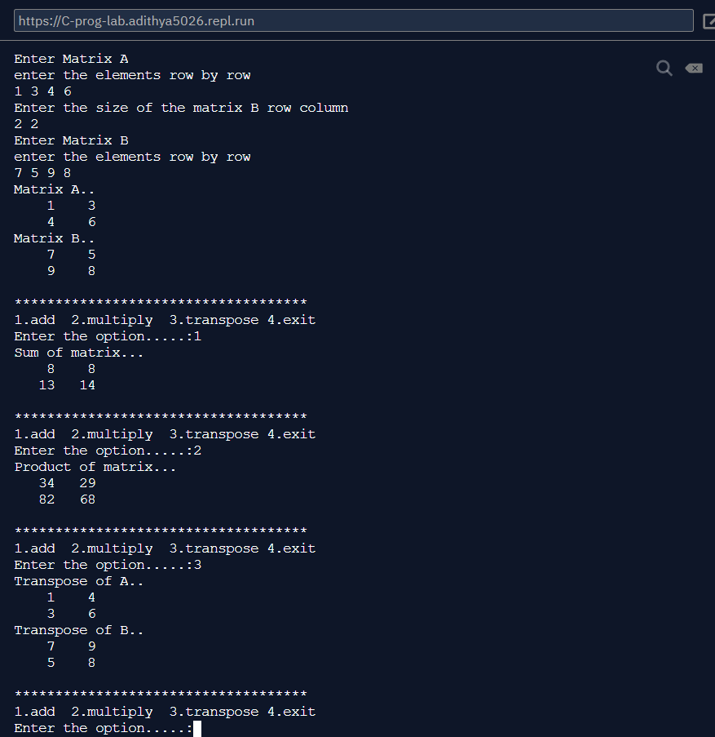

EXP No.: 19

ADDITION AND MULTIPLICATION USING POINTERS

AIM

Program to :

i) add two numbers

ii) swap two numbers using a user defined function using pointers

PROGRAM

#include <stdio.h>

void swap(int *xp, int *yp)

{

int temp = *xp;

*xp = *yp;

*yp = temp;

}

void add( int *xp, int *xq, int *xs)

{

*xs = *xp + *xq;

}

int main()

{

int x, y,s=0;

printf("Enter Value of x \n");

scanf("%d", &x);

printf("Enter Value of y \n");

scanf("%d", &y);

add(&x,&y,&s);

swap(&x, &y);

printf("Sum of the numbers = %d\n", s);

printf("After Swapping: x = %d, y = %d \n", x, y);

return 0;

}

OUTPUT

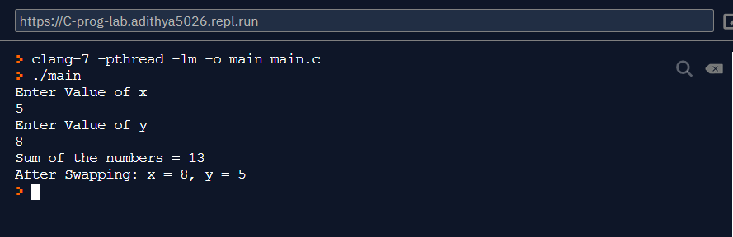

EXP No.: 20

ARRAYS USING POINTERS

AIM

Program to Input and Print the elements of an array using pointers.

PROGRAM

#include <stdio.h>

int main()

{

int arr[100];

int n, i;

int * ptr = arr;

printf("Enter size of array: ");

scanf("%d", &n);

printf("Enter elements in array:\n");

for (i = 0; i < n; i++)

{

scanf("%d", (ptr + i));

}

printf("Array elements: \n");

for (i = 0; i < n; i++)

{

printf("%d\n", *(ptr + i));

}

}

OUTPUT

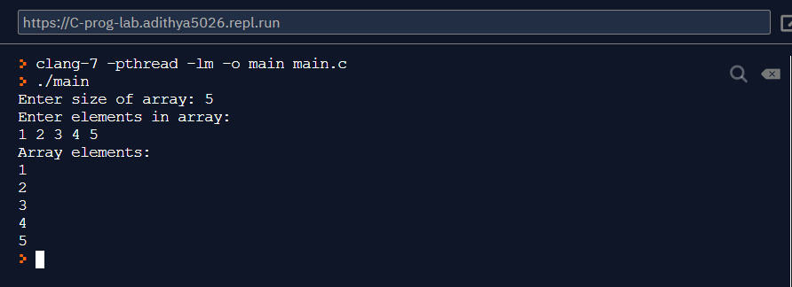

EXP No.: 21

SUM OF ELEMENTS IN AN ARRAY USING POINTERS

AIM

Program to Compute sum of the elements stored in an array using pointers and user defined function.

PROGRAM

#include <stdio.h>

#include <stdlib.h>

int arraysum(int *ptr,int n)

{

int sum=0,i;

for (i = 0; i < n; i++)

{

sum=sum+ *(ptr + i);

}

return sum;

}

int main()

{

int arr[100];

int n, i,sum=0;

int * ptr = arr;

printf("Enter size of array: ");

scanf("%d", &n);

printf("Enter elements in array:\n");

for (i = 0; i < n; i++)

{

scanf("%d", (ptr + i));

}

sum=arraysum(arr,n);

printf("Array elements sum=:%d \n",sum);

}

OUTPUT

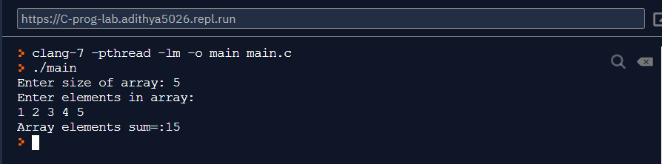

EXP No.: 22

FILE HANDLING

AIM

Program to Create a file and perform the following

i) Write data to the file

ii) Read the data in a given file & display the file content on console

iii) append new data and display on console

PROGRAM

//Program to write data to the file file.txt

#include <stdio.h>

#include <stdlib.h>

#include <string.h>

int main()

{

FILE *fp;

char t[1000];

char filename[100];

printf("enter the filename:\n");

scanf("%s",filename);

fp=fopen(filename,"w");

if(fp==NULL)

{

printf("Error opening file..");

exit(1);

}

getchar();

printf("Enter the data to be written in file and press enter \n");

fgets(t,1000,stdin);

fputs(t,fp);

printf("File written successfully");

fclose(fp);

}

//Program to read data from file.txt and display it.

#include <stdio.h>

#include <stdlib.h>

int main()

{

FILE *fp;

char t[100];

char filename[100];

printf("enter the filename:\n");

scanf("%s",filename);

fp=fopen(filename,"r");

if(fp==NULL)

{

printf("Error opening source file..");

exit(1);

}

while((fgets(t,sizeof(t),fp)!=NULL))

{

printf("%s",t);

}

fclose(fp);

}

// program to append append new data and display on console

#include <stdio.h>

#include <stdlib.h>

int main()

{

FILE *fp;

char t[100];

char filename[100];

printf("enter the filename:\n");

scanf("%s",filename);

getchar();

fp=fopen(filename,"a");

if(fp==NULL)

{

printf("Error opening source file..");

exit(1);

}

printf("Enter the contents to append:\n");

fgets(t,sizeof(t),stdin);

fputs(t,fp);

fclose(fp);

fp=fopen(filename,"r");

printf("File contents after appending...\n");

printf("********************************\n");

while(fgets(t,sizeof(t),fp)!=NULL)

{

printf("%s",t);

}

fclose(fp);

}

OUTPUT

//Program to write data to the file file.txt

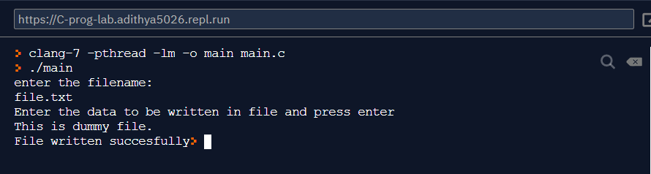

//Program to read data from file.txt and display it.

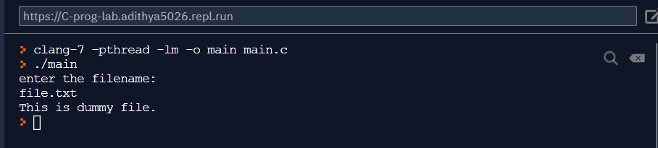

// program to append append new data and display on console

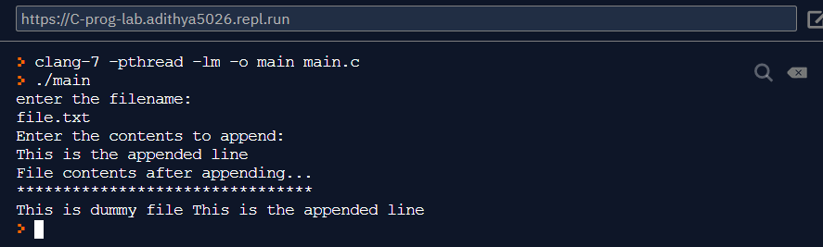

EXP No.: 23

NUMBER OF CHARACTERS WORDS AND LINES IN A FILE

AIM

Program to Open a text input file and count number of characters, words and lines in it; and store the results in an output file

PROGRAM

#include <stdio.h>

#include <stdlib.h>

int main()

{

FILE *fp;

char fname[50];

int ch;

int nl=0,nc=0,nw=0;

printf("Enter the file name:\n");

scanf("%[^\n]",fname);

fp=fopen(fname,"r");

if(fp==NULL)

{

printf("Error opening file..");

exit(1);

}

ch=getc(fp);

while(ch!=EOF)

{

if (ch=='\n') nl++;

if(ch==' ') nw++;

nc++;

ch=getc(fp);

}

fclose(fp);

printf("Number of lines=%d Number of words=%d ,Number of characters = %d,\n",nl,nc,nw+nl);

printf("results are written into result.txt file..\n");

fp=fopen("result.dat","w");

fprintf(fp,"Number of lines=%d \n Number of words=%d \n,Number of characters = %d,\n",nl,nc,nw+nl);

fclose(fp);

}

OUTPUT

